

Atip-Avenir Program 2026

Guide for applicants

Key dates

- September 15th, 2025 at 00:01 am CET: Publication of the Call
- October 3rd, 2025, at 00:01am CET: Opening of online submission of applications
- November 7th, 2025 at 10:00 am CET: Deadline of online submissions
- Mid-April 2026: Announcement of the shortlisted candidates for interviews
- June 9th to June 11th, 2026: Interviews of the shortlisted candidates
- June / early July 2026: Announcement of the final list of laureates
- From January 2027: Start of the contract

Contacts

Catherine CAVARD
atip-avenir@cnrs-dir.fr

Davide TAMPELLINI
atip-avenir@inserm.fr

A- Eligibility and evaluation criteria:

A1. Eligibility
Atip-Avenir grants are open to researchers of any nationality who may reside in any country in the world when applying.
Projects must be developed within a CNRS (CNRS Biology as primary affiliation) and/or Inserm host laboratory in France.

Identifying a host lab IS NOT a prerequisite for applying to the program and IS NOT a criterion for selection However, in the case of pre-selection for the interview, it is advisable to have identified a few potential host laboratories.

Applicants must have defended their PhD (or equivalent doctoral degree) more than 2 years and less than 8 years ago : PhD defence September 15th, 2017 and September 15th, 2023.

The eligibility period is calculated based on the date of the successful PhD defence / (“date de soutenance” in french). For applicants where no defence/viva was organised in the awarding institution, the applicant should provide written confirmation from that awarding institution stating that no defence/viva was organised and indicating the date when the PhD was approved.

Projects must be developed in a lab where the applicant:
- Has not worked for more than 18 months (reference date: September 15th, 2025)
- Will not have any previous mentors (of PhD and/or postdoctoral work).

Laureates of grants similar to the Atip-Avenir program (e.g., ANR JCJC program to start an independent research group or ERC grants) are not eligible. However, laureates with an ANR JCJC program are eligible for an Atip-Avenir grant if their ANR contract is finished and if they develop their project in a different lab.

Only one application per call is allowed, and applicants cannot apply to more than two different Atip-Avenir calls.

A2. Exemptions

Medical doctors
For medical doctors, an MD alone will not be accepted as equivalent to a PhD. Eligible medical doctors (MDs) must provide certificates of both basic studies (MD) and a PhD, or proof of an appointment that requires doctoral equivalency (e.g., post-doctoral fellowship, professorship appointment). Additionally, candidates must provide information on their research experience, including peer-reviewed publications, to demonstrate the equivalence of their overall training to a PhD.

Clinical training
For clinicians (e.g., Ecole de l'Inserm Liliane Bettencourt), extensions will be considered based on the documented amount of clinical training received by the Principal Investigator after the award of the first eligible degree and up until the call deadline.

- Teachers (MCU-PH, PU-PH)
For teachers (MCU-PH, PU-PH), the rule that the project must be developed within a structure where the scientist has not worked for more than 18 months does not apply.

Leaves
- Maternity Leave: The effective elapsed time since the PhD award will be reduced by 12 months for each child born before or after the PhD award.

- Paternity Leave: The effective elapsed time since the PhD award will be reduced by the amount of paternity leave taken for each child born before or after the PhD award (supporting documents are required).

-Medical leave: The effective elapsed time since the PhD award will be reduced by the amount of medical leave taken before or after the PhD award (supporting documents are required).

- National Service: The effective elapsed time since the PhD award will be reduced by the amount of national service leave taken after the PhD award.

A3. Evaluation

Excellence is the sole criterion upon which Atip-Avenir grants are awarded. This criterion will be applied to evaluate both the research project and the principal investigator.
Evaluation criteria:

• Quality of the applicant: This includes the applicant's background and publications, its ability to conduct ground-breaking research with creative independent thinking and the required scientific expertise to successfully execute the project.

• Quality of the scientific approach: This considers the ground-breaking nature and potential impact of the research project and the suitability of the proposed methodology (including timescales, resources) to achieve the goals of the project. The development of novel methodology is also considered.

• Quality of the management: This assesses the applicant's ability to manage the project and lead a team.

B- Items of the application:

- Online Form (submission website address: https://www.eva3.inserm.fr/login )

Curriculum Vitae

- Scientific file containing the description of your research project in 10 pages maximum

PhD diploma

- ONE Letter of recommendation (strongly suggested but not essential)

- Host laboratory and host university (if identified)

Registration through the Submission Website is mandatory.

https://www.eva3.inserm.fr/login
You will find all the templates of the documents in the field
“Candidate information” on the welcome form
All the documents and forms must be written in English

B1. Online Form

To be filled in online from October 3rd , 2025 at 00:01am CET
to November 7th, 2025, 10:00am CET
Find below the requested information requested in the online form.
- Personal Data

Personal Data
Date of birth Nationality Civility
Number of children Initial training Actual Position Organism
Cell phone number

Laboratory/organization Laboratory/organization City
Country
Name of the director

PhD
Date of the PhD defence PhD Supervisor
Country

Host laboratory
Have you identified a host laboratory? Structure requested (if any)
Institution Inserm code CNRS code
Name of laboratory/organization City
Name of the Director Starting date

Works and projects

Selected panel (your choice based on the topic of your research project, See below the research areas of the 4 AA panels)
First AA Panel Second AA Panel

Project title -255 characters-
Keywords -255 characters-
Abstract -3000 characters-

Your 5 main publications

Proposed referees
Indicate some experts in the field (working abroad)
Last name / First name / email

Excluded referees
Indicate the names of up to three reviewers to exclude from the review process
Last name / First name /email / Justification (conflicts of interest: direct competitor, collaboration in progress)

Requested documents
Scientific file PhD diploma CV

B2. Curriculum Vitae
Download the template from the section ‘Candidate information’ on the welcome form.

Personal Information
Last name First name Gender Position
Personal postal address Professional phone number Email
Date of birth of child(ren)
Date and duration of military service and/or paternity leave

¹Provide an email address that will be valid until early 2027 and that is checked regularly

Cursus
PhD degree (year, place) PhD supervisor
Other diplomas (year, place)

Professional experience
Degrees
HDR (French habilitation for PhD supervision)

Professional experience: -2000 characters-
Describe the PhD, post-doctoral training, current position and any additional professional training. For each position, indicate the period, the Institution, the country and the name of your mentor(s).

Grants: -1000 characters-
Indicate the grants obtained as principal investigator

Teaching and supervision experience: -400 characters-
University teaching responsibilities (academic year, university, level undergraduate, master, postgraduate) Supervision

Awards and scientific prizes -400 characters-
Names and date

Learned societies -400 characters-
Membership(s) of learned societies, discussion groups (period of duty)

- Institution where you currently work
Title of the research laboratory
Name of the Head of the research laboratory and the team leader
Postal address of the research laboratory
Date of arrival in this laboratory

B3. Scientific file
Download the template from the section ‘Candidate information’ on the welcome form.
Formatting references: please use the reference style outlined by the International Committee of Medical Journal Editors (ICMJE), also referred to as the “Vancouver” style.
Once completed, upload it in your personal space on the website

B4. PhD diploma
To upload on the website

B5. Letter of recommendation
One letter, written in English, stating the ability of the candidate to conduct his/her own research project should be directly sent by email by their authors to: atip-avenir@inserm.fr

B6. Host laboratory and university form
Applicants may submit their proposal without an identified host laboratory.

Important: The applicants will have to develop their projects within a research unit
- In France
- In which he/she has not been working for more than 18 months (reference date: September 15th, 2025)
- Will not have any previous mentors (of PhD and/or postdoctoral work).

Download the host laboratory and university template from the section ‘Candidate information’ on the welcome form.

Once completed and signed by the head of laboratory and by the research vice-president of the university, send it by e-mail to: atip-avenir@inserm.fr
Do not upload it on the EVA3 website

B7.Some universities have expressed interest in joining the program. For more information, please visit their websites:

- Université de Lorraine (I-SITE LUE) : http://lue.univ-lorraine.fr/fr/article/recruitement-future-leader- young-group-leader-Atip-avenir-universite-de-lorraine

- Université de Montpellier (I-SITE MUSE) : dred-srech@umontpellier.fr
- Université Clermont Auvergne (I-SITE CAP 20-25) : https://cap2025.fr/
- Université Côte d'Azur (IDEX UCAjedi) : https://univ-cotedazur.fr/universite/ucajedi-lidex-duniversite-cote-dazur
- Université Aix-Marseille (A*Midex 3.0 21-24) : https://www.univ-amu.fr/system/files/2021-05/Feuille%20de%20route%20strat%C3%A9gique%20AMidex%203.0%20-%20%202021-2024_0.pdf
- Université de Tours

C- Submission of the application

C1. Registration

Registration can be done online from October 3rd, 2025, at 00:01am.
- Connect to https://www.eva3.inserm.fr/login and follow the steps below
- Preferably use : Google Chrome or Mozilla Firefox
- The online form must be written in English
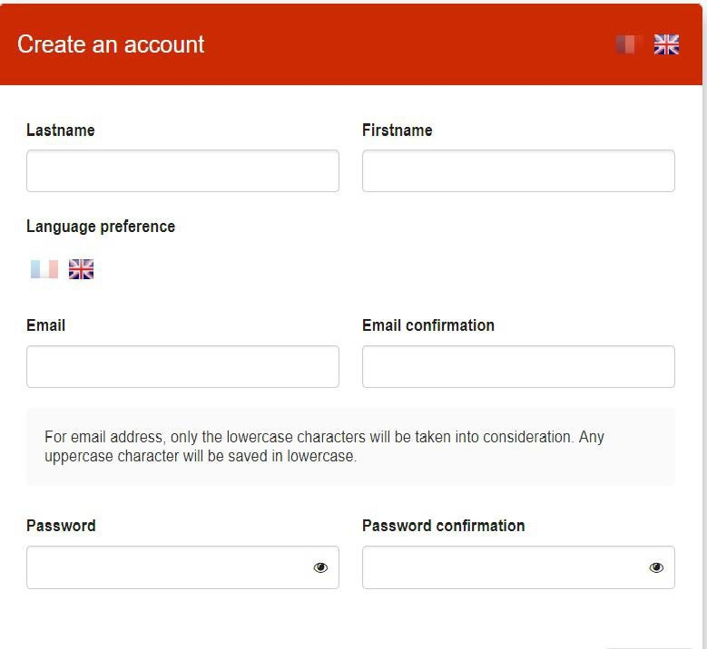
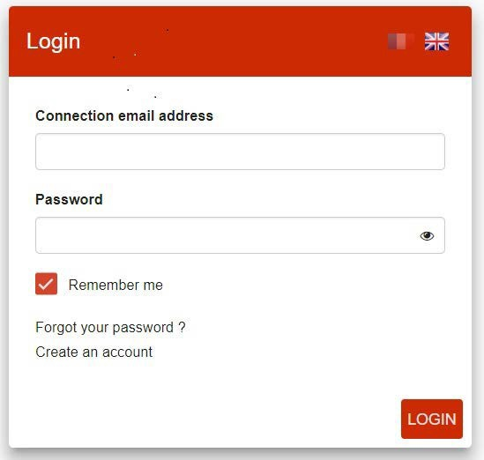
If you don’t have
an account

For Inserm researchers the account is already created.
The connection email address (login) is your Inserm email address and the password is the one used for your Inserm email address.

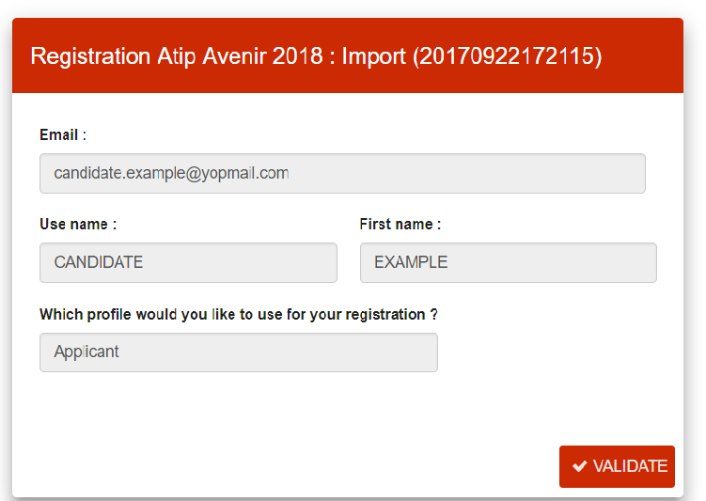
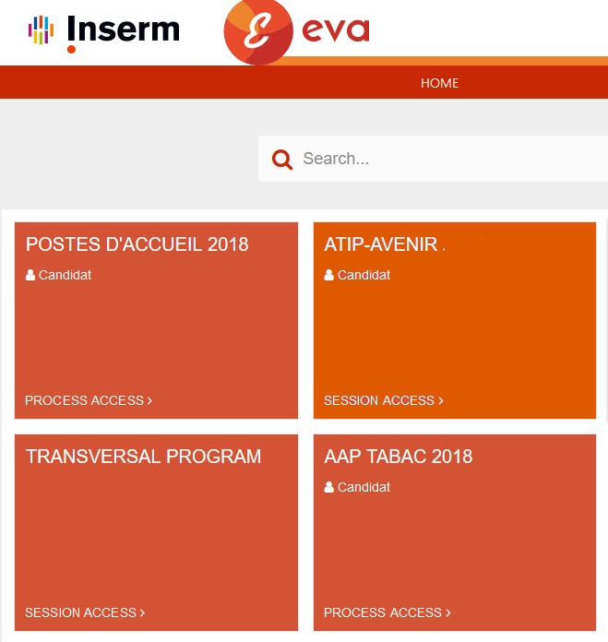
Once you have an account, you can access the Atip-Avenir session and validate your registration

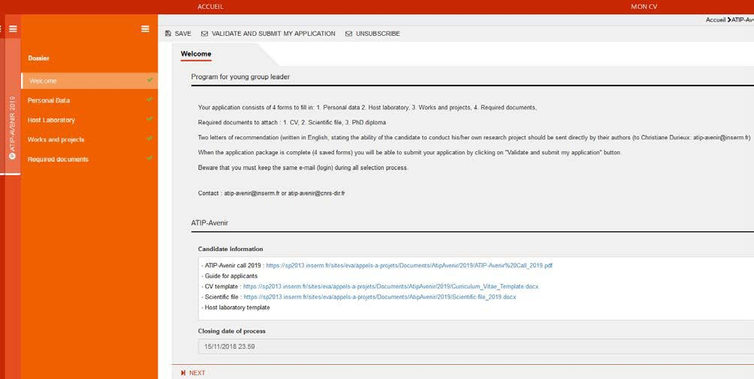
C2. Online submission must be completed by November 7th, 2025, 10 am CET
When you save the form (top of the page) or click next, the symbol will turn green  if all items are completed.
Guide and templates
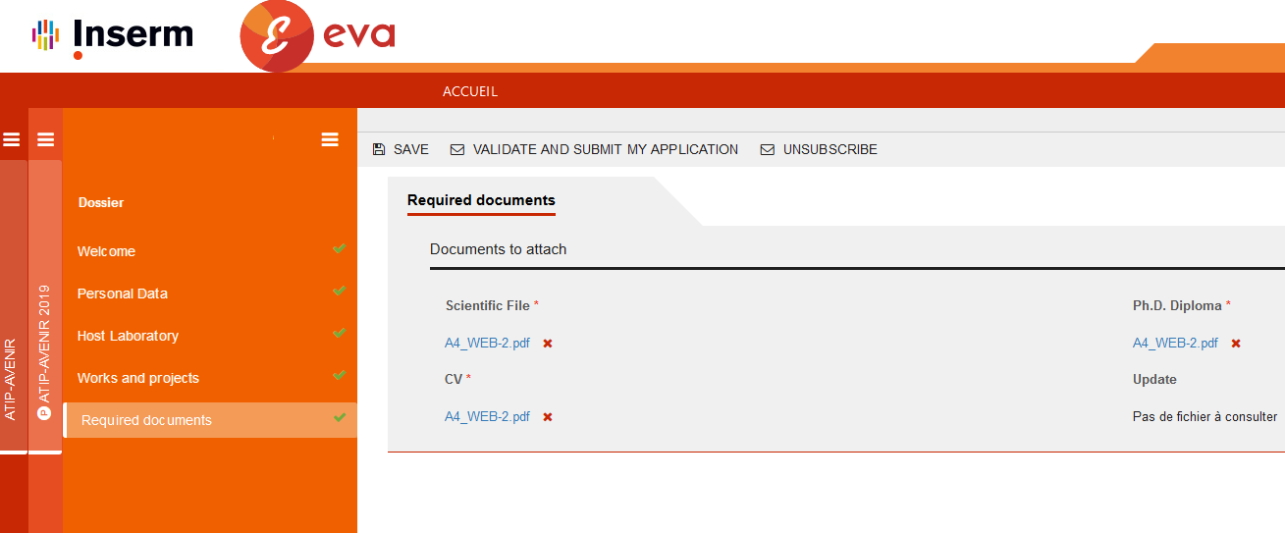
Upload all the needed documents:

When all forms are completed, click on ‘Validate and submit my application’:
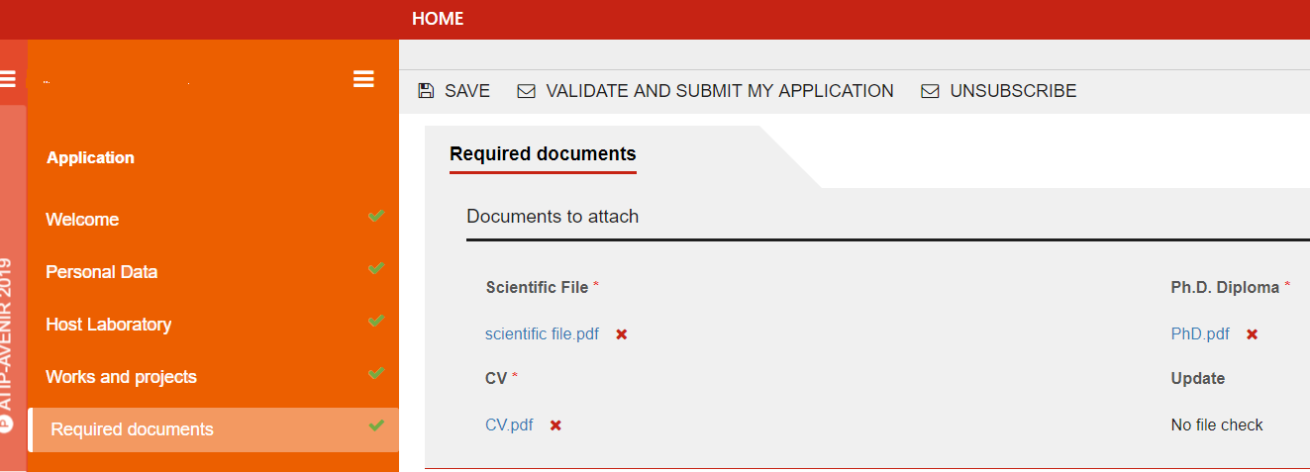

You can still modify your application until the deadline. Do not forget to validate your final proposal.
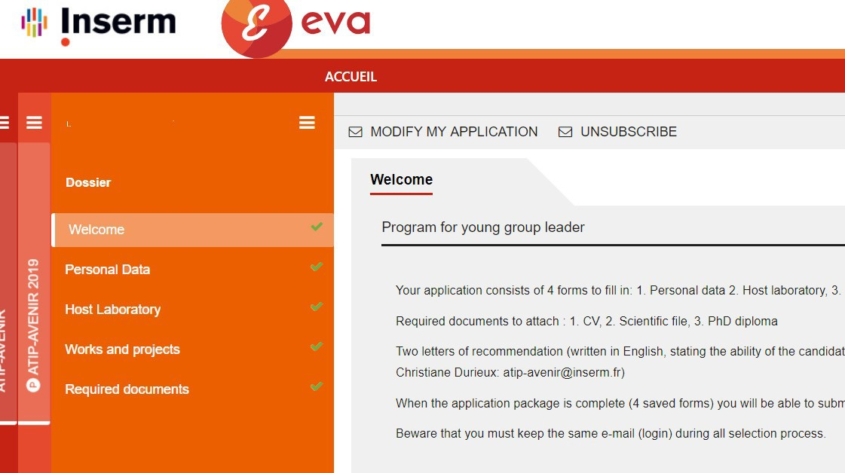

D- Results

After the evaluation of the proposal, you will be informed about the outcome via the Inserm and CNRS Biology websites. You will be notified by email when this information becomes available.

Feedback on the evaluation will typically be sent within a few months after the publication of the results.

E- Atip-Avenir Evaluation panels with the covered fields of research

AA1 Molecules of Life and Integrative Biology:

- Molecular biology, biochemistry, structural biology, molecular biophysics, synthetic and chemical biology, drug design, innovative methods and modelling,
- Genetics, epigenetics, genomics and other ‘omics studies, bioinformatics, systems biology, genetic diseases, gene editing, innovative methods and modelling, ‘omics for personalized medicine

AA2 Cell Biology, Development and Evolution:

Structure and function of the cell, cell-cell communication;

Embryogenesis, tissue differentiation, organogenesis, growth, development, developmental and evolutionary genetics, organoids, stem cells,

Regeneration, development of cell-based therapeutic approaches for tissue regeneration, Functional imaging of cells and tissues,

Theoretical modelling in cellular, developmental and regenerative biology,

Physics of biological systems,

Non-canonical biological models and mechanisms

AA3 Physiology, Pathophysiology, Immunity, Infection and Microbiology:

Organ and tissue physiology, comparative physiology, physiology of ageing, pathophysiology inter- organ and tissue communication,

Endocrinology, nutrition, metabolism, interaction with the microbiome,

Non-communicable diseases including cancer and immunity-related diseases (except disorders of the nervous system),

The immune system, related disorders and their mechanisms,

Innovative immunological tools and approaches, including therapies,

Biology of infectious agents and infection, biological basis of prevention and treatment of infectious diseases,

Pharmacology and toxicology,

Nanomedicine, Technologies, genetic tools and biomarkers for prevention, diagnosis, monitoring and treatment of diseases

AA4 Neurosciences and Cognition:
- Nervous system development, homeostasis and ageing, nervous system function and dysfunction,
- Systems neuroscience and modelling, biological basis of cognitive processes and behavior,
- Neurological and mental disorders,
- Cognitive basis of human development, developmental disorders,
- Comparative cognition,
- Attention, perception, action, consciousness, learning, memory, cognition in ageing, reasoning, decision-making,
- Innovative methods and tools for neuroscience

Applicants submitting epidemiological or technological projects, or projects that involve approaches or themes not explicitly listed in the generic titles of the panels above should select the AA panels that are most closely aligned with their project's theme.

